ProgramEquity

Summary of the Project
Please write a paragraph describing the high-level overview of your project, including any relevant links or details that will help to contextualize the work fellows will be doing. | Add an introduction to the “customers” for the Amplify platform - what problem is it trying to solve? For whom? How is it different from the status quo?  This project is based on VueJS which is a comprehensive stack celebrated for the ease of creating single page apps. Our approach is community based so you’ll work with Tech for Social Good MERL research groups as well as internal team meetings which are optional but help navigate async open source workflows. From a technical standpoint, this means we follow a DevSecOps framework which allows you to learn code similar to enterprise architecture of tech companies. Along with traditional roles such as full-stack and UX/UI, you also have the opportunity to be enabled on GitHub’s newest features in architecture such as automations, containerization, and database abstraction. Here’s a snapshot of how we work:  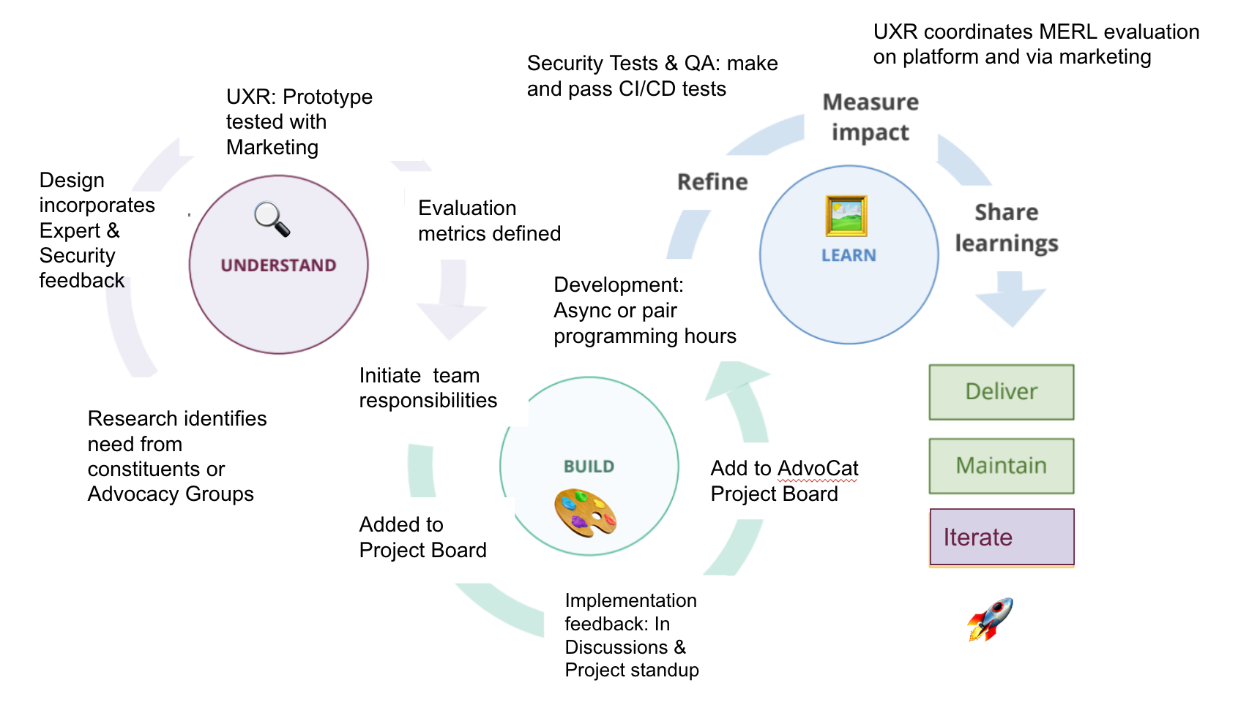

Stakeholder Information
Please list all stakeholders (name, email, title/role) who will be involved with the project.

Name | Email | Role
Manisha Priyadarshini | manisha@github.com | Product/Project Management
Glenn Pidu | glenn@piludu.io | Frontend lead
Najwana Red | Theunnamedred@gmail.com | Volunteer Experience Eval
Jonathan Wallace | wallace@github.com | Backend lead
James Greene | jamesmgreene@github.com | Architecture lead

Fellow Technical Onboarding
Please explain how fellows should prepare to work on your project. On top of setting up a local environment, this may include: completing tutorials, watching videos, and/or reading articles.

Additionally, please outline ‘starter tasks’ that the fellows can work on at the beginning of the fellowship to familiarize themselves with the project and set up their environment. These could be simple issues to engage with that allow the fellows to build an understanding of the code base and the features/issues that they will be working on.

Our onboarding is more interactive as well since we’re using the new codespaces feature which makes it easy for people to work without a local environment setup (this is where new contributors used to lose 3-4 hours that we’re not helping them get started faster)!

We also supplement this with onboarding sessions, pair hours as well as office hours that are walkthroughs of the project for people to learn while working with one another both async and synchronously.

Tutorials/Videos | Contribution Guide, Onboarding sessions, team meetings, Codespaces, 1:1s
Documentation | Readmes help you get started and the team’s workflows, Code documented within file, Wikis, Docs host project overviews, Discussions host team meeting notes
Starter Tasks/Issues | See Section below

Docs:

illustrate how we work together through models

Wikis: 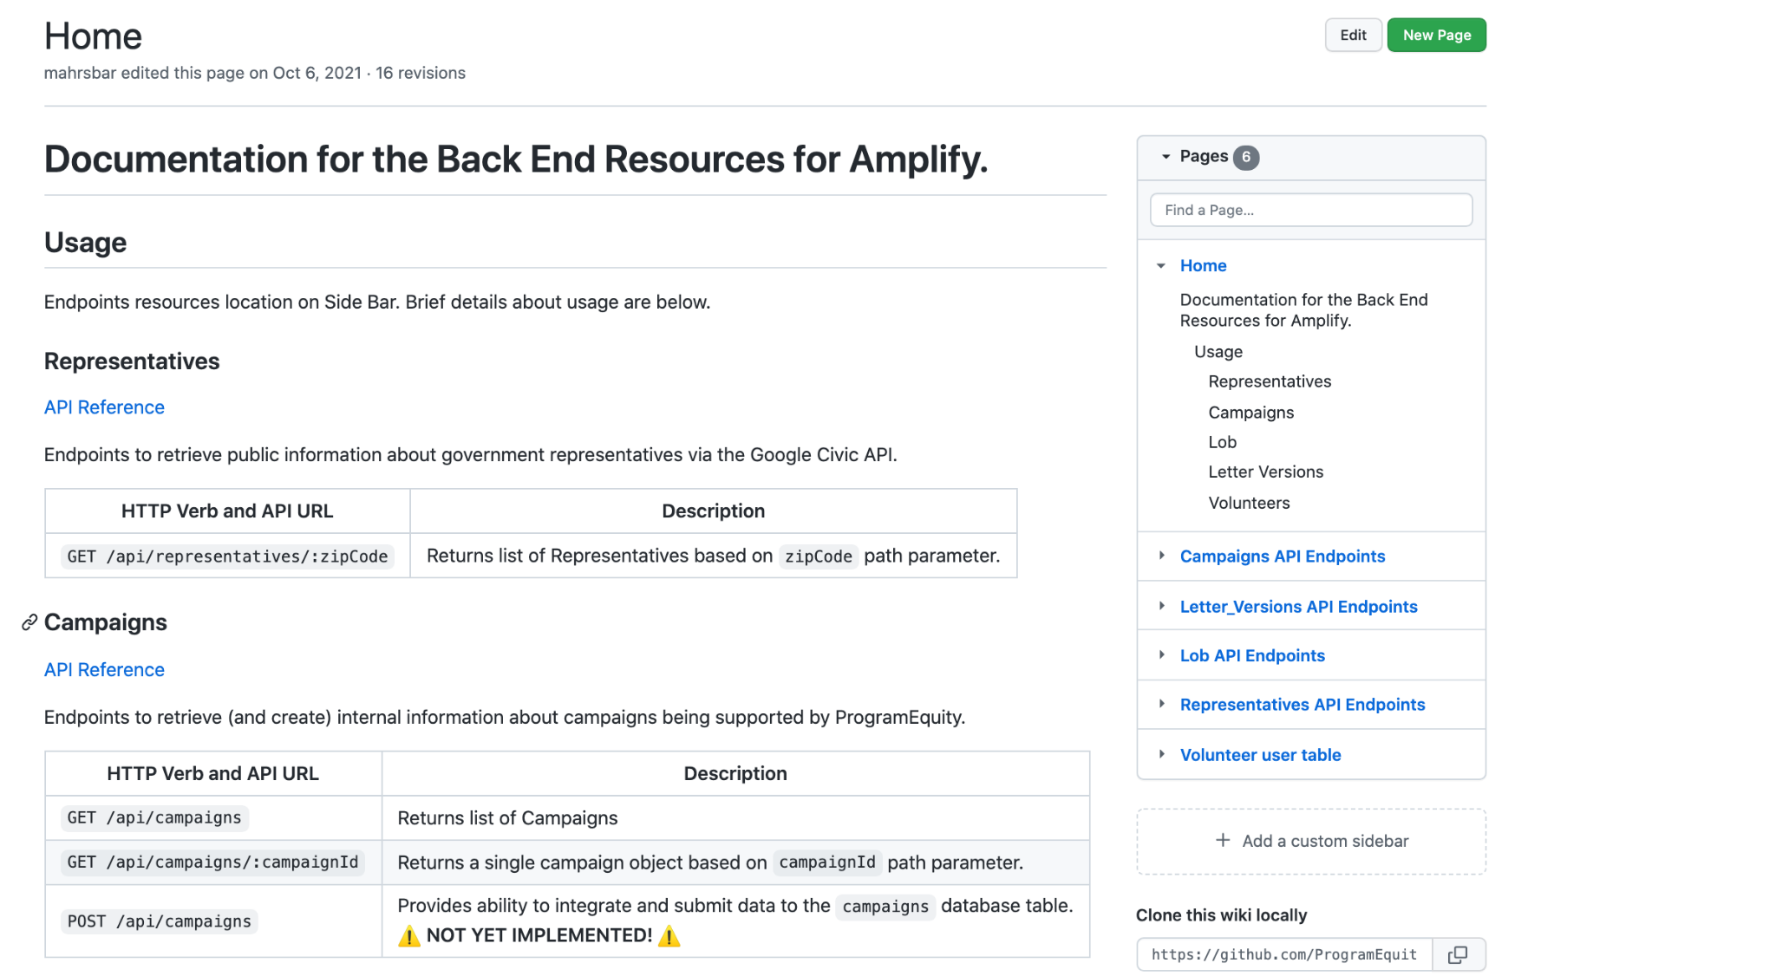

Readmes:
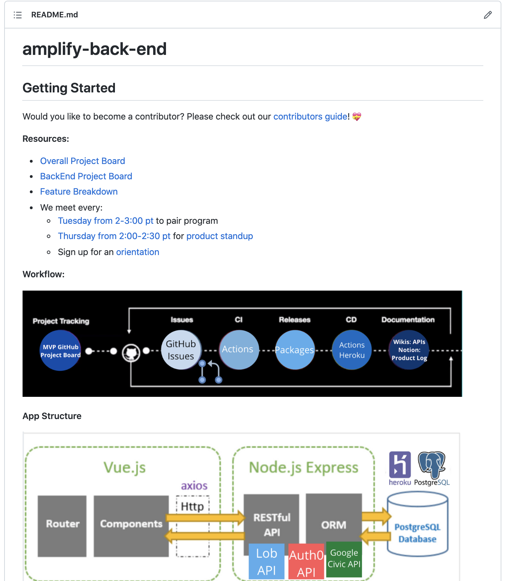

Contribution Guideline and using codespaces:
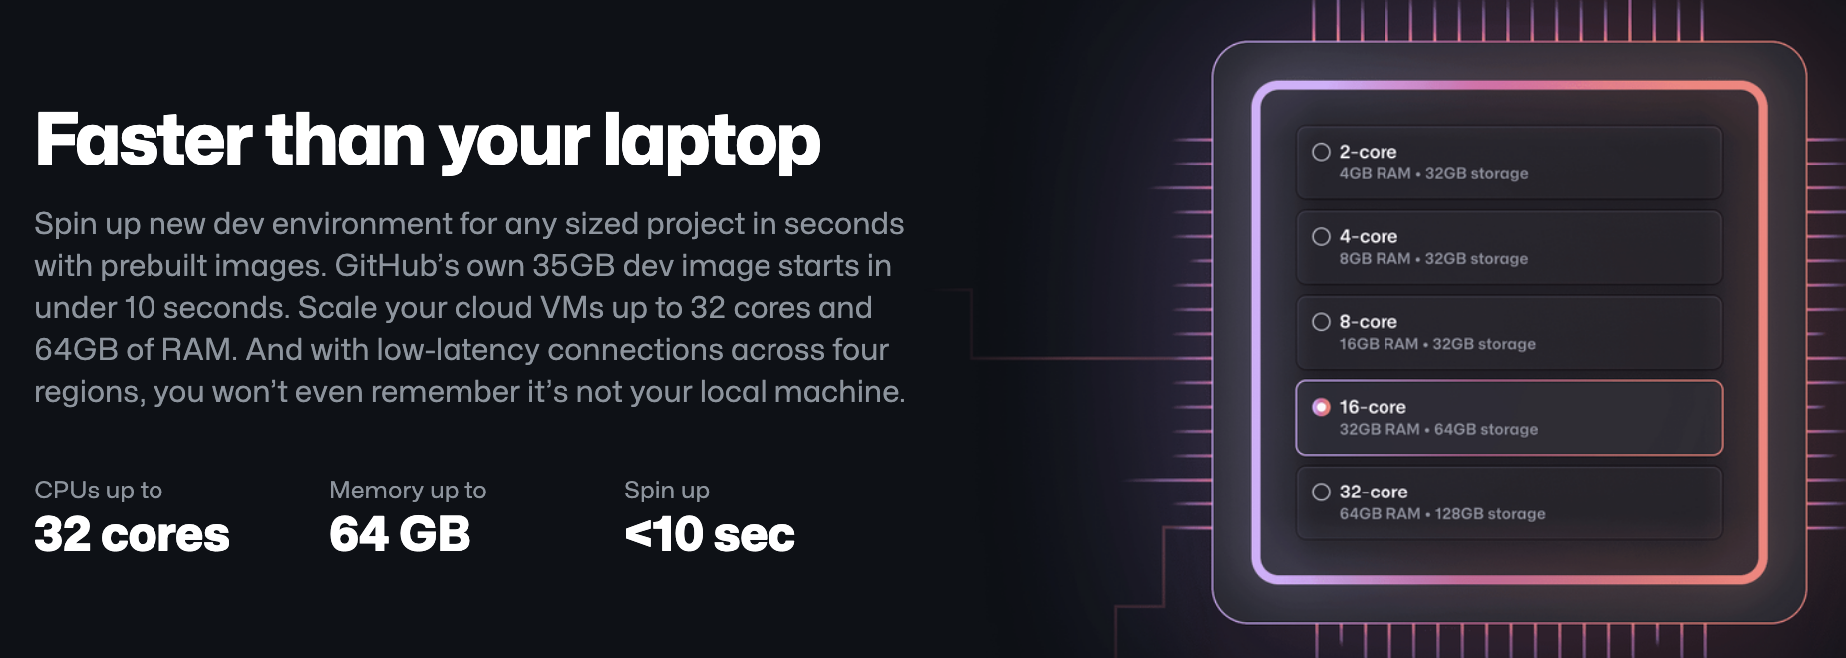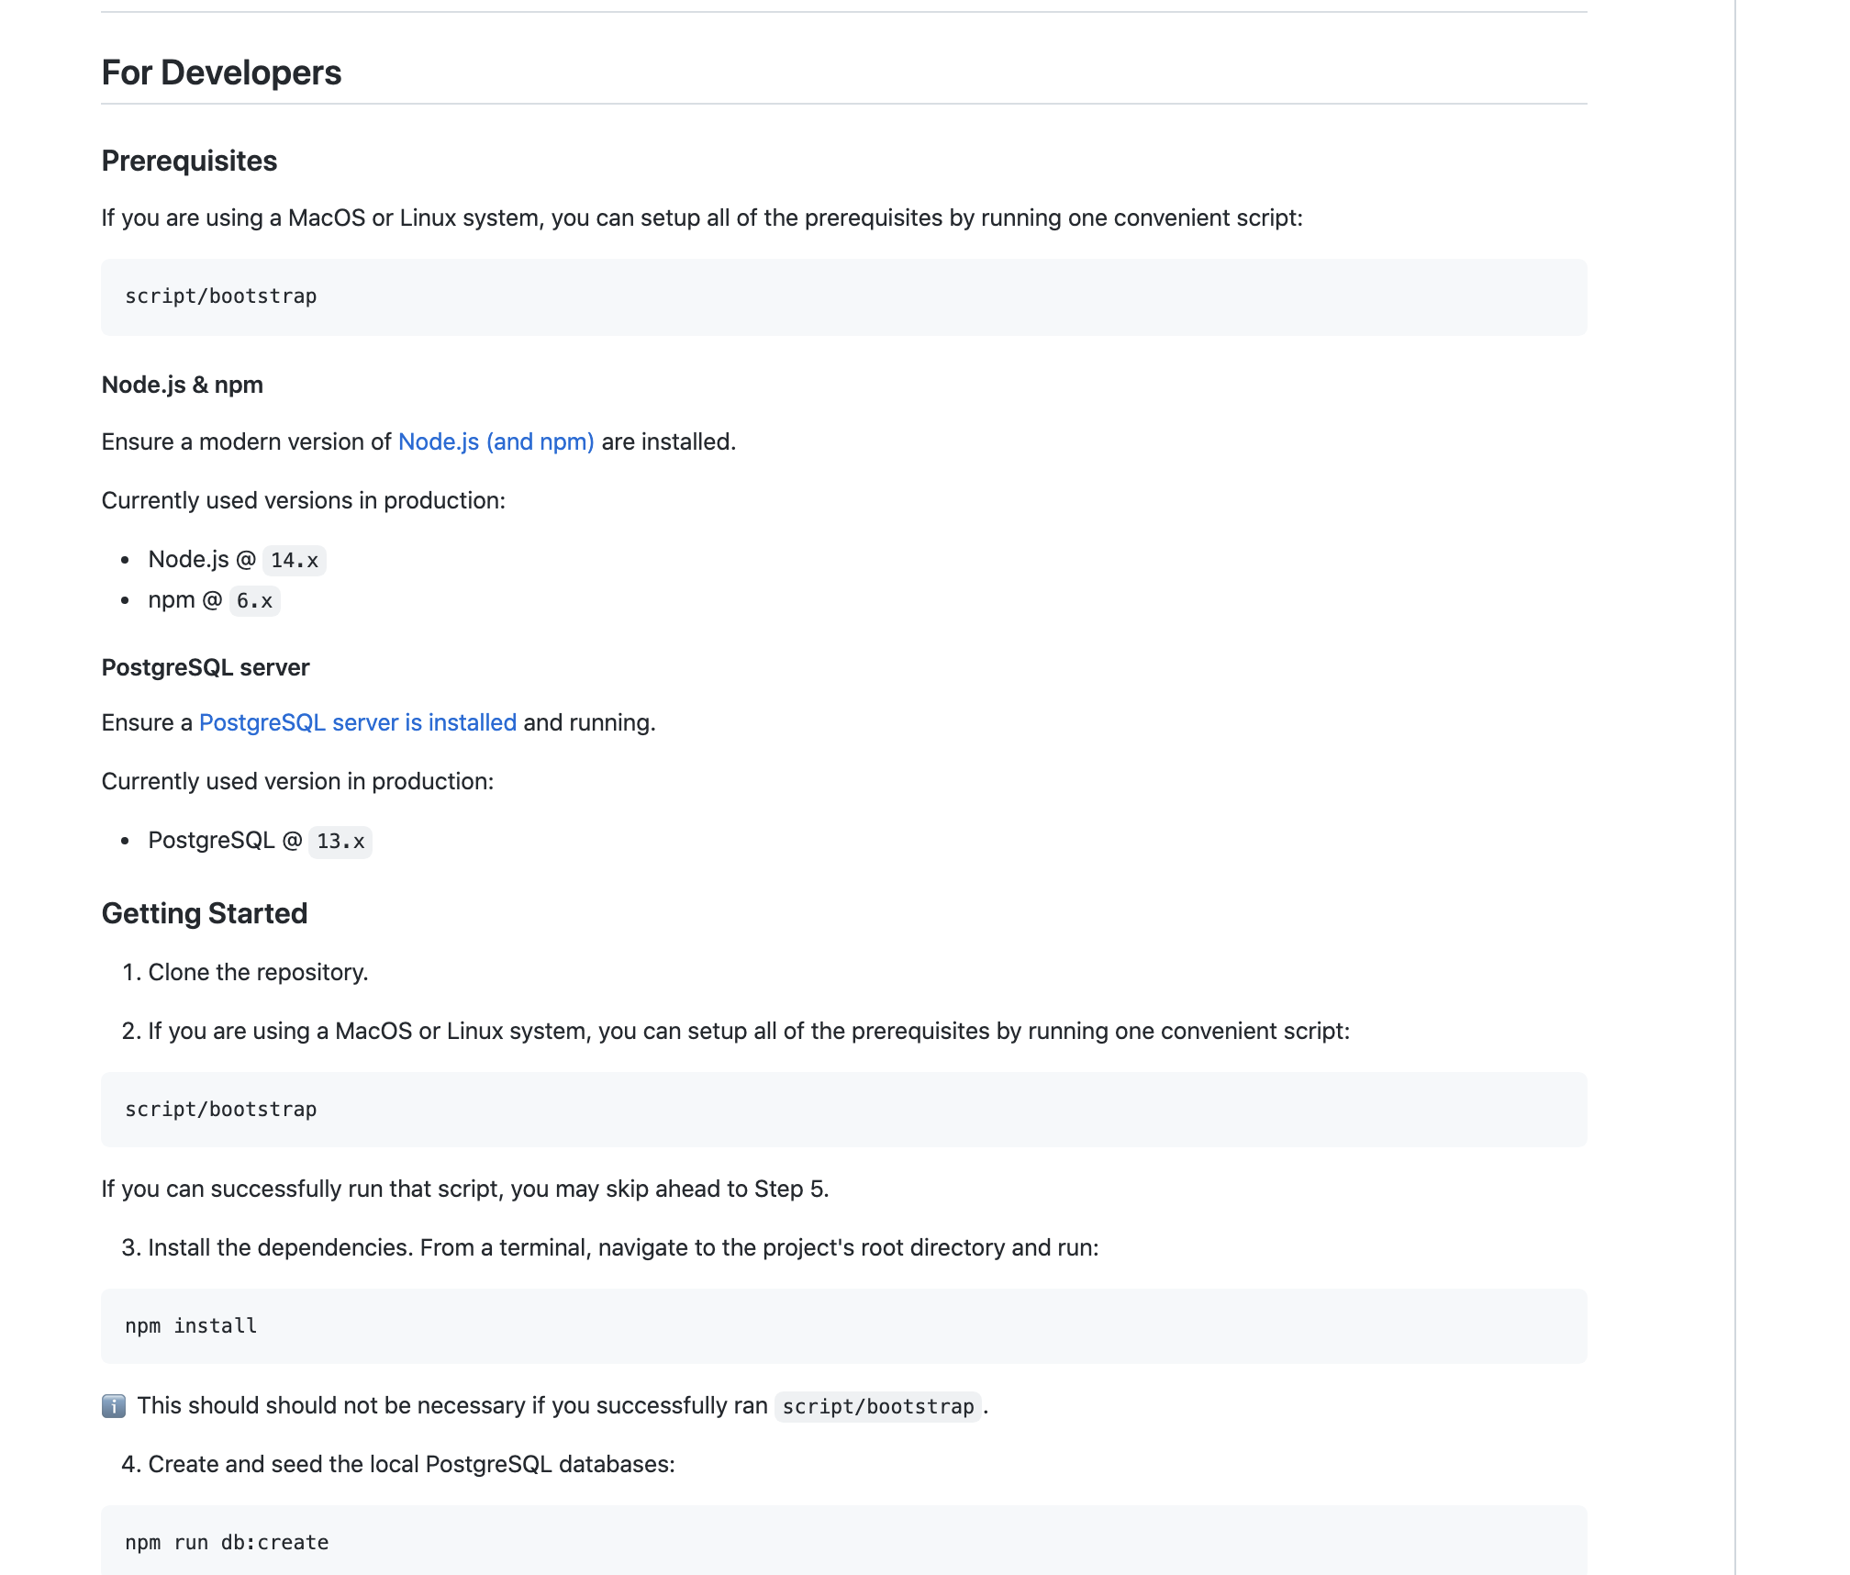

Discussions & Slack:
where are we in the project and need one another’s help

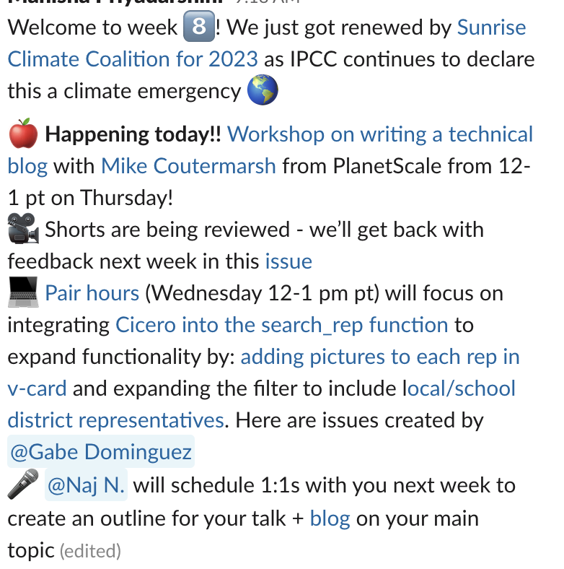
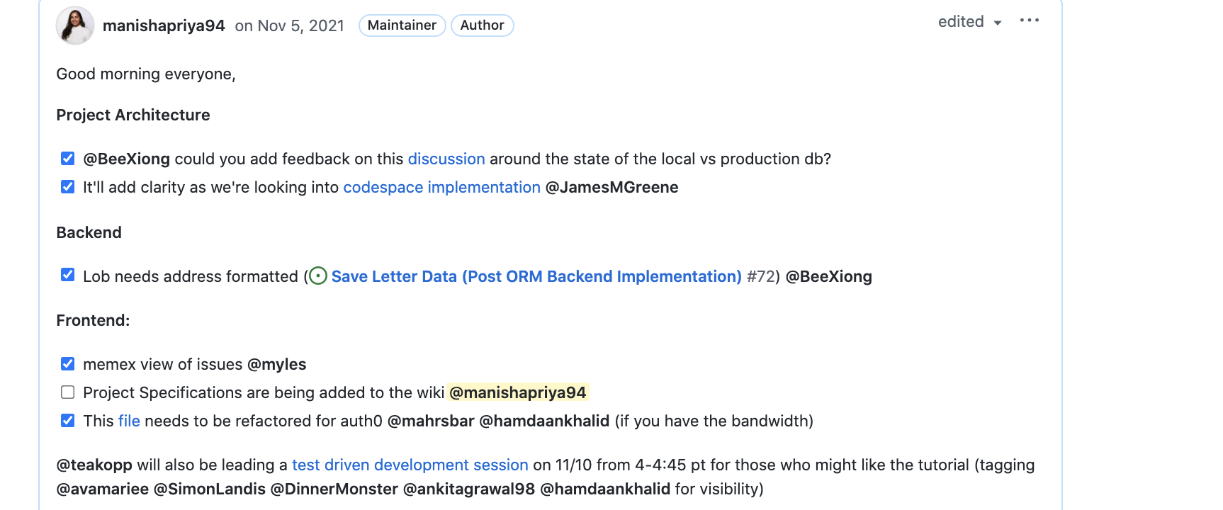

Starter task/Issues
Use copilot to ramp fast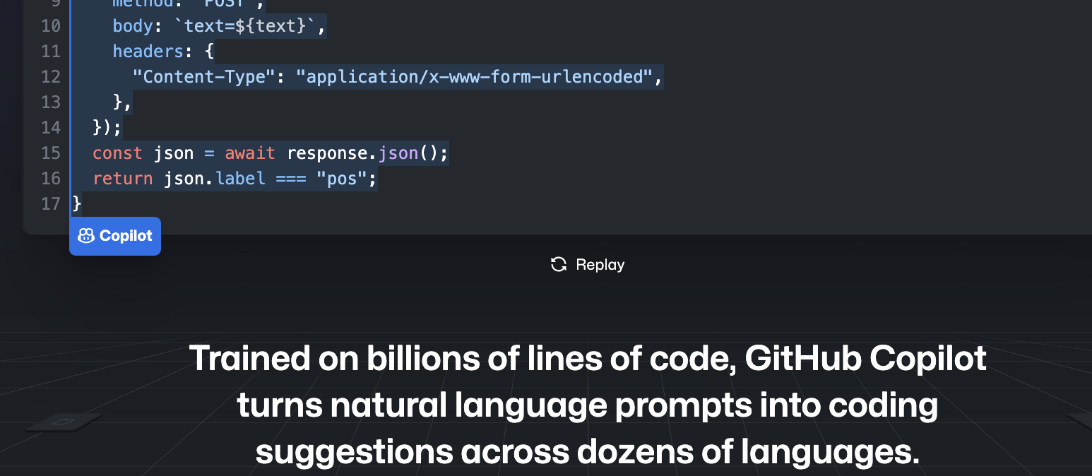

‘good first issue’
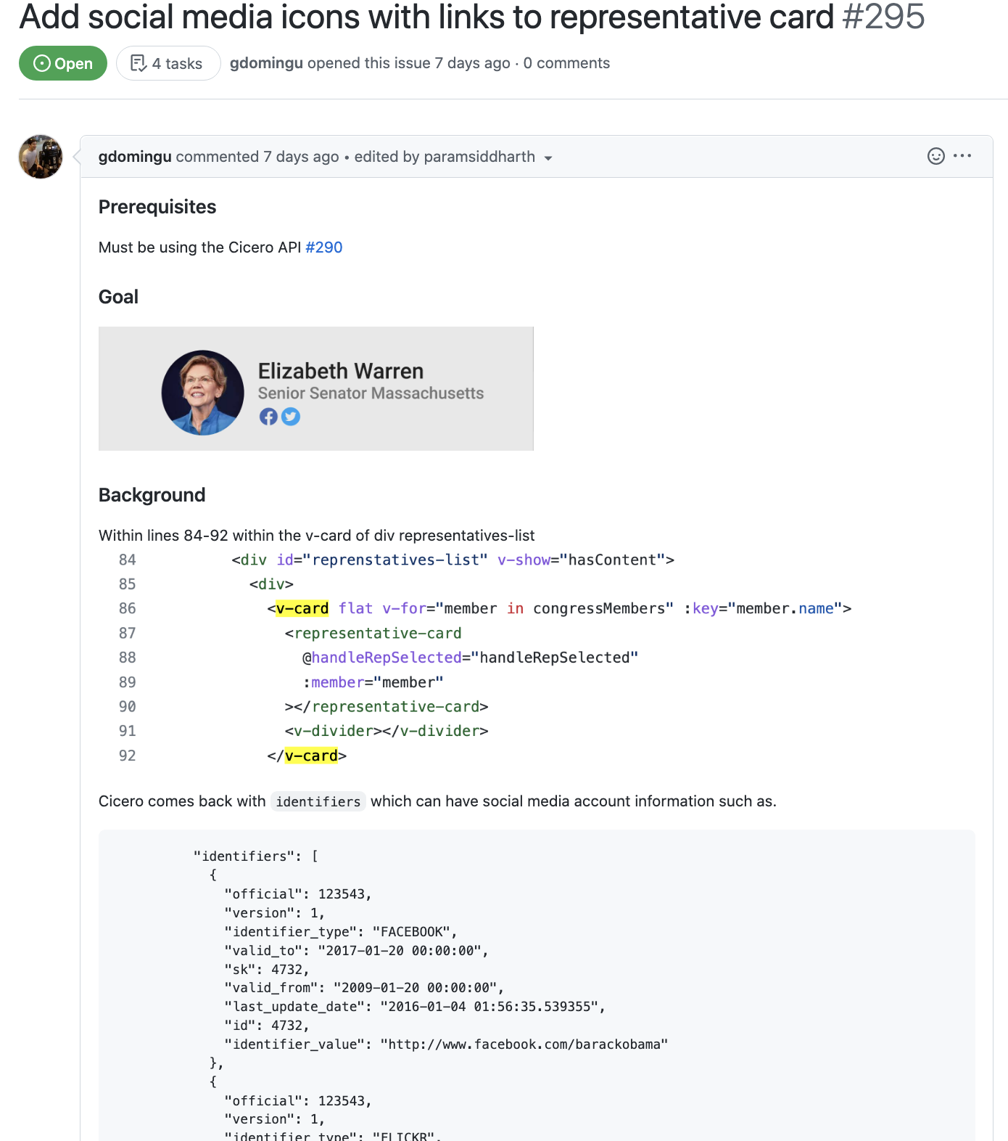
‘intermediate’
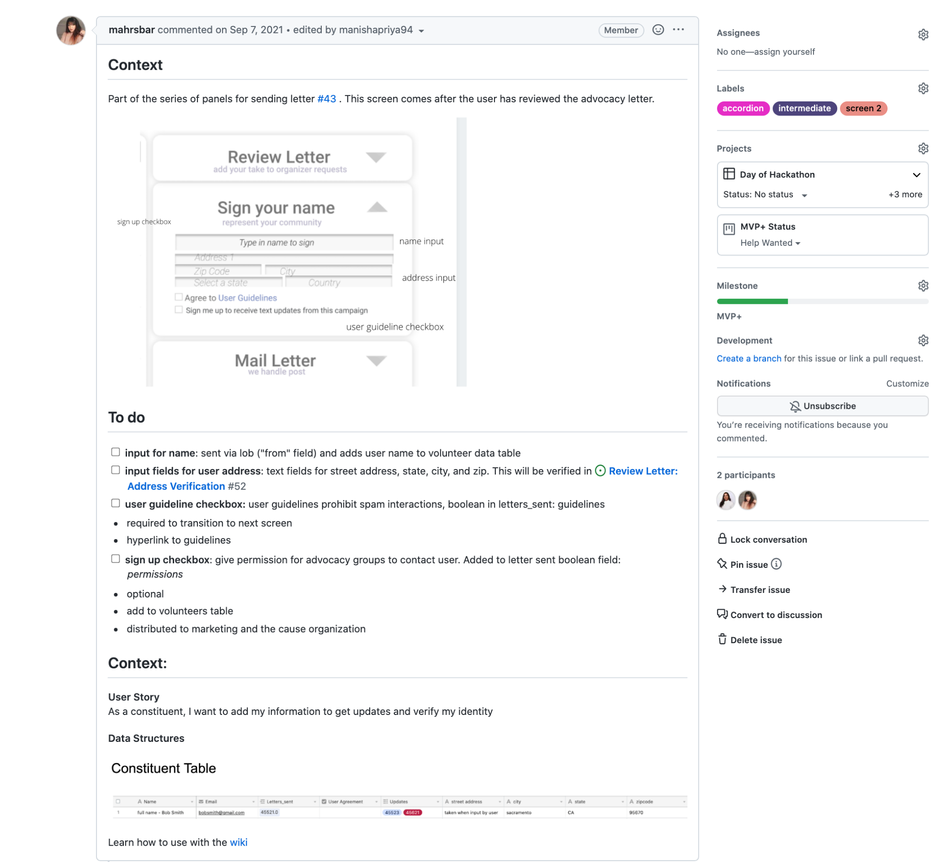

Deliverables + Timeline
Please identify and describe the deliverables for your project(s) and the ideal deadline for each. This may include features or issues you would like the fellows to complete by the end of the fellowship. There are two general approaches we’ve seen be successful:
- One “large” issue with critical research and design milestones
- A list of many “smaller” issues that increase in complexity

Our project boards are refreshed bimonthly and will differ by the time students onboard so we decided to share with you how we’ve structured the program in 3 week blocks and provided a screenshot of our current project board and what each issue of complexity can look like.

Program Schedule: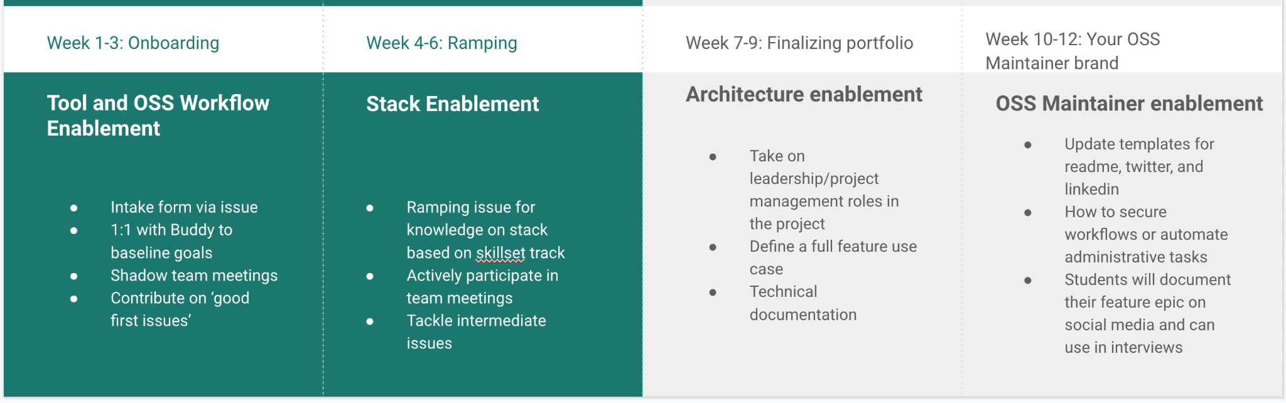

Project Board and Issues
Labels are defined by scope (epic vs feature vs batch), which feature it contributes to, and the ease level (good first issue and intermediate)
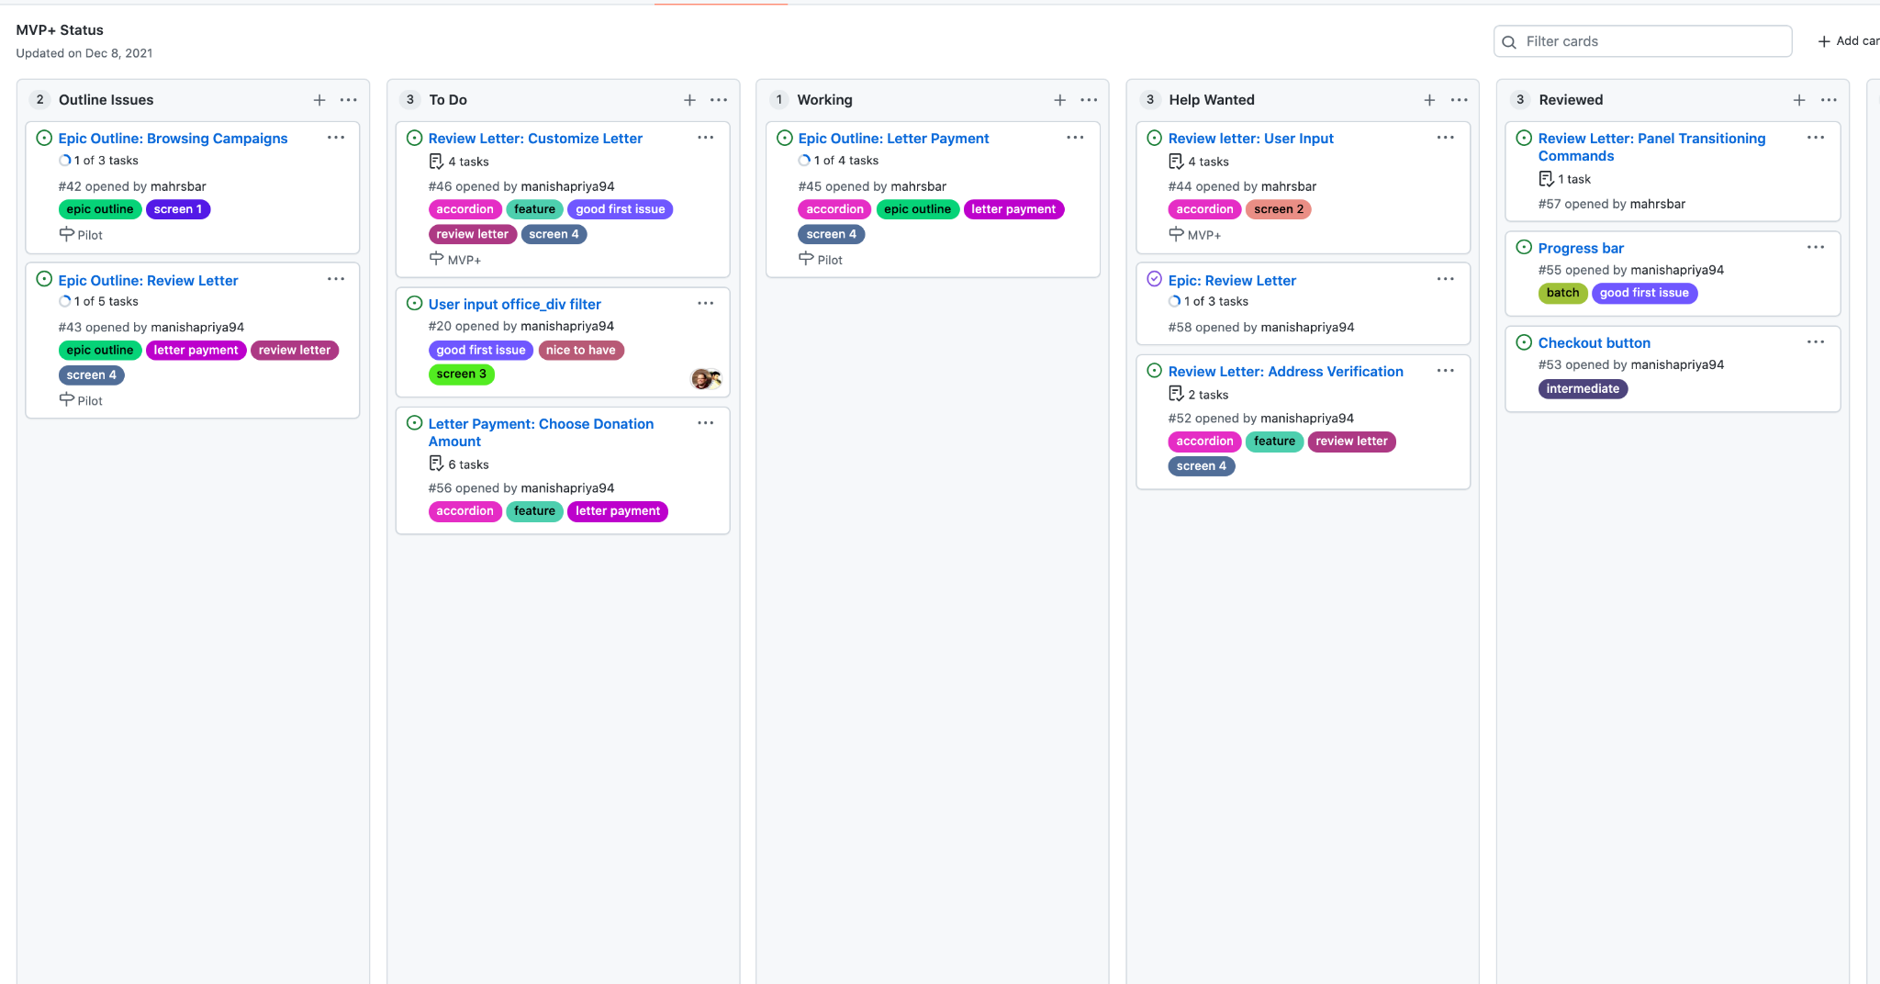

How ramping will go:

MLH | Fullstack Dev (deck of all student enablement)
ONBOARDING | MLH Fellows
5/31 Week 1  - Intro to GitHub  - CTCI - Best Practices  - Remote Work Best Practices | - 🏗 Intro to project, set up codespaces  - 💻 Decide between Backend & Frontend  - 🏗 1:1 with Mahrs, Ankit  - 🌱 Intake form
6/6 Week 2  - Time Management  - CTCI - Arrays | - 🏗 Shadow team meetings  - 🍎 Workflows: GitHub Flow (James)  - 🏗 Concepts: Vuetify & VueJs  - 💻 Introduce good first issues
6/13 Week 3  - Communication Skills  - CTCI - String Manipulation & RegEx  - Bash Scripting | - 🍎 Webapp structure and APIs (.env, package json)  - 🏗 Understand feature components  - 🏗 Understanding Actions  - 💻 Finish Good first issues
RAMPING
6/20 Week 4  - Resume Building  - CTCI - File Input & Output  - Bash Scripting Cont. | - 🏗 Deep dive into working with APIs  - 🍎 Contribute to documentation TechDocs pair hour  - 💻 Finish another good first issues
6/27 Week 5  - Low Code Development  - Intro to Blockchain  - CTCI - Linked Lists  - Testing | - 🏗Logic Models and Data Structures  - 🍎Action Workflows  - 💻 Pick bug to resolve
Week 6  7/5  - Technical Interviews  - Behavioral Interviews  - Docker / Containers  - CTCI - Stacks & Queues | - 🍎 Typescript Test Driven Workshop  - 🏗Logic Models and Data Structures  - 💻 Write tests out for APIs
PORTFOLIO BUILDING
7/11 Week 7  - Personal Branding  - Resume Reviews  - CTCI - Trees | - 🍎 How to write a technical blog  - 🏗 Portfolio Project Intro  - 💻 Outline steps for an Epic implementation
7/18 Week 8  - GraphQL API  - GitHub Actions  - CTCI - Binary Search Trees | - 🏗 Data structures and mapping  - 💻 Create batch tasks for Epic implementation
7/25 Week 9  - Monitoring Concepts  - Collaboration Best Practices  - Open Source Best Practices  - CTCI - Heaps | - 🏗 Project review and debugging  - 💻 Implement batch tasks  - 🌱 Indigenous led sustainability
8/1 Week 10  - Growth Mindset in Tech  - Learning in Public  - CTCI - Graphs  - Negotiation | - 🍎 What to highlight in a resume  - 🏗 Project review and debugging  - 💻 Implement batch tasks
8/8 Week 11  - Networking in Tech  - Preparing Yourself for a Role  - Serverless Computing  - CTCI - Dynamic Computing | - 🍎 Interview workshop  - 💻 Review and debug tasks  - 🏗 Project review and debugging
8/15 Week 12  - OOP in JavaScript  - Security 101  - CTCI - Review | - 🌱 Finalize github readme, linkedin, resume  - 💻 Finalize epic deliverables  - 🏗 Demo/Hack logistics
8/22 Demo day!! (hack?) | - 🌱 Demo Day/Hackathon with NEAR or Change.org

MLH Partner Success Contact
- Matt Dillabough

Pod Leader Questions

